Feedback: Structural and Behavioural Models
System Name: Unplanned Eating Pattern Detector
By
Kiran Kumar Palsa

1. Use Case Diagram
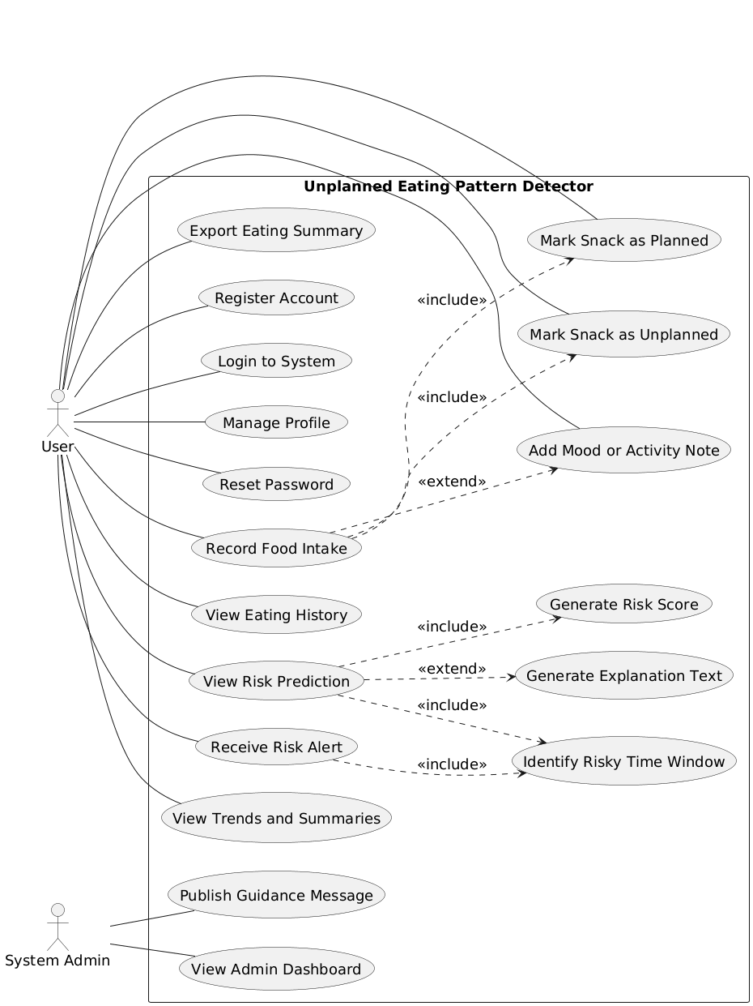
Figure.1 Use Case Diagram

2. Class Diagram
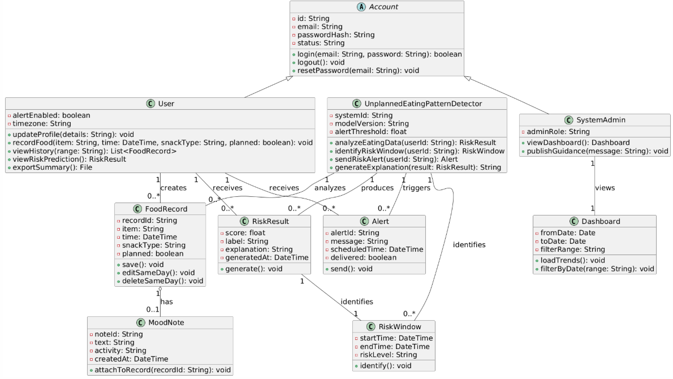
Figure.2 Class Diagram

3. Object Diagram
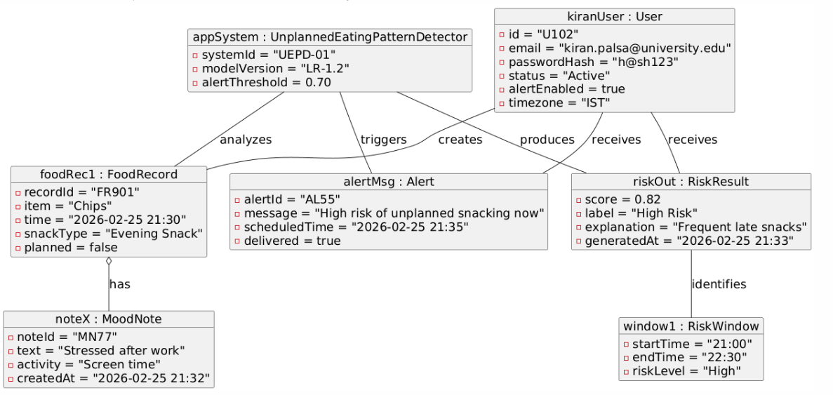
Figure.3 Object Diagram

4. Sequence Diagram
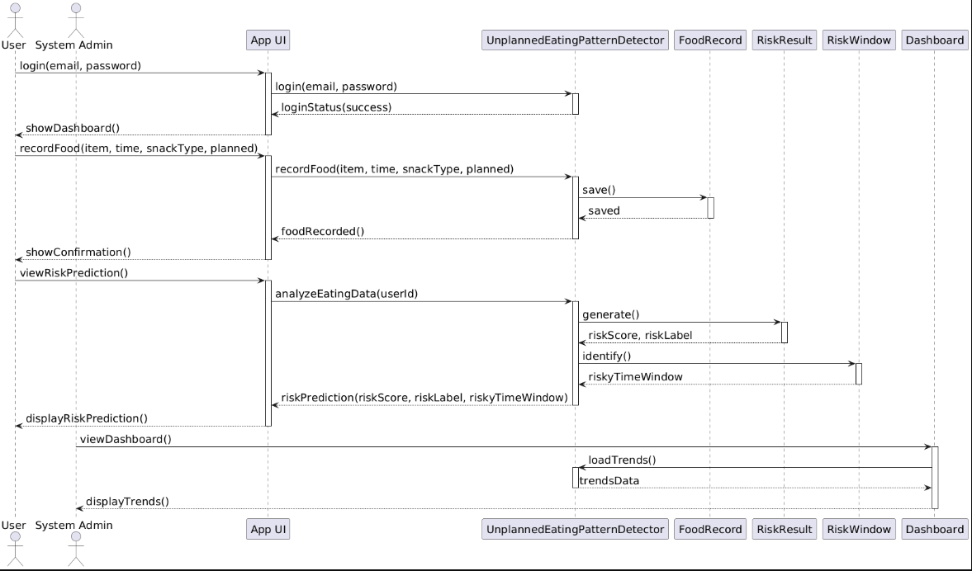
Figure.4 Sequence Diagram

5. Behavioural State Machine
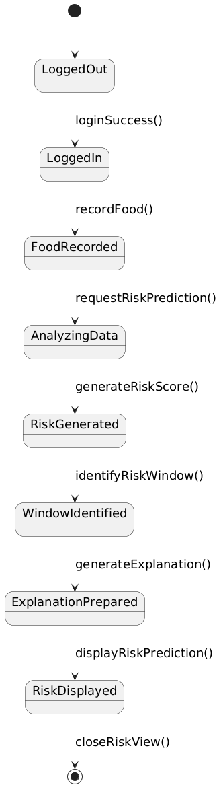
Figure.5 Behavioural State Machine (User views risk prediction)

6. Words Connecting: functional to structural and behavioural model
I created the structural and behavioral models by carefully reviewing the approved use cases and identifying the main objects involved in each action. First, I listed the people and things the system must store information about, such as users, food records, risk results, alerts, and the system that coordinates analysis. These became the core classes in the class diagram, and I added attributes and operations based on what each use case needs to perform. Next, I built the object diagram to show a real example of how these classes work together at one moment when a user records food, views risk prediction, and receives an alert. Then, I created sequence diagrams from the use cases to show how messages move between objects step by step during login, food entry, risk analysis, and alert delivery. Finally, I added a state machine to show how the system moves through states while generating and displaying risk predictions. This process ensured the structural and behavioral models directly reflect the functional model.
Traceability Table (Use Case to Classes Mapping):
Use Case (ID & Name) | Classes Used
UC-1 Register Account | Account, User
UC-2 Login to System | Account, User, UnplannedEatingPatternDetector
UC-3 Manage Profile | User
UC-4 Reset Password | Account
UC-5 Record Food Intake | User, FoodRecord, MoodNote, UnplannedEatingPatternDetector
UC-6 View Eating History | User, FoodRecord
UC-7 View Risk Prediction | User, UnplannedEatingPatternDetector, RiskResult, RiskWindow
UC-8 Receive Risk Alert | User, UnplannedEatingPatternDetector, Alert
UC-9 View Trends and Summaries | User, Dashboard
UC-10 Export Eating Summary | User, FoodRecord
UC-11 Publish Guidance Message (Admin) | SystemAdmin, Dashboard
UC-12 View Admin Dashboard | SystemAdmin, Dashboard
UC-13 Mark Snack as Planned | User, FoodRecord
UC-14 Mark Snack as Unplanned | User, FoodRecord
UC-15 Add Mood or Activity Note | User, MoodNote, FoodRecord
UC-16 Generate Risk Score | UnplannedEatingPatternDetector, RiskResult
UC-17 Identify Risky Time Window | UnplannedEatingPatternDetector, RiskWindow
UC-18 Generate Explanation Text | UnplannedEatingPatternDetector, RiskResult

